**TRAFFIC OVERVIEW (Oct 24, 2018-Oct 29, 2018)**

**WORKFLOW OPTIMIZATION**

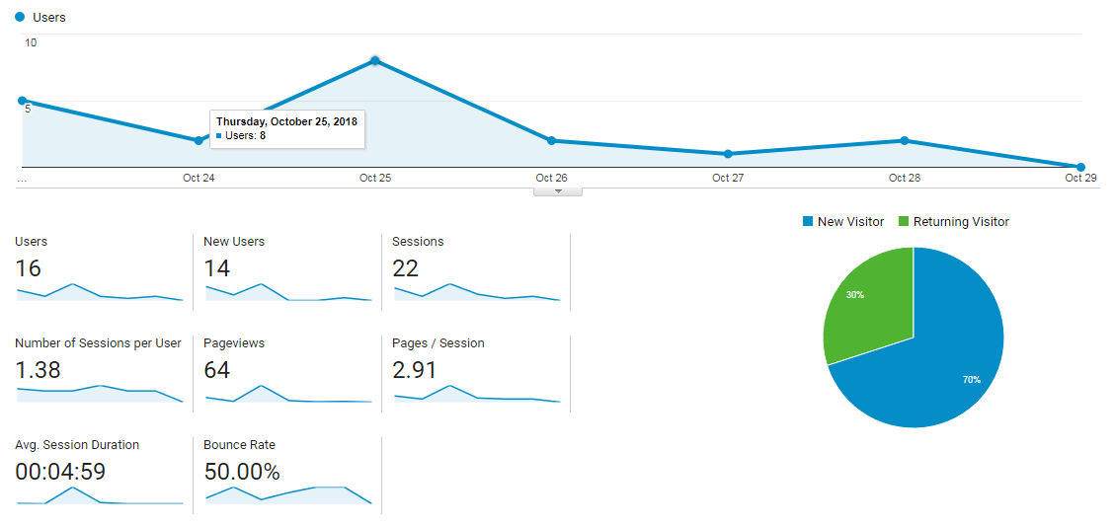

**GEOGRAPHY:**

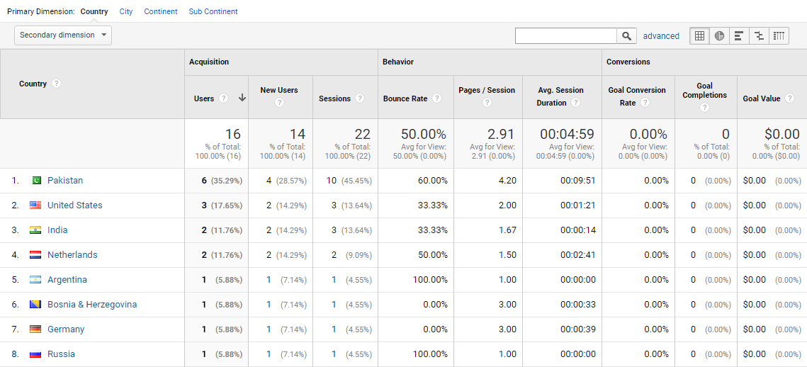

**DEVICES:**

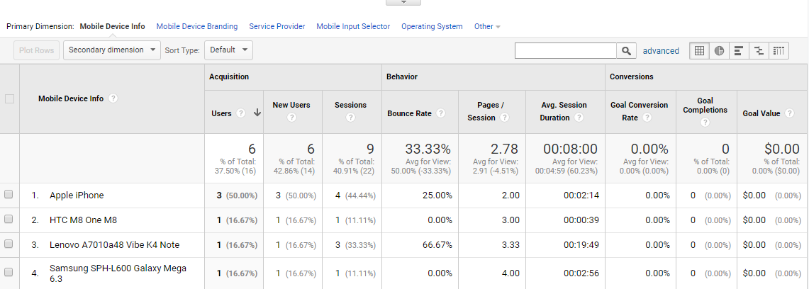

**TRAFFIC SOURCE:**

